* Website Traffic Analysis SQL
* Somya Jain

Q1. Finding the Top Traffic Sources

select utm_source,utm_campaign,http_referer,count(distinct website_session_id) from `mavenfuzzyfactory`.`website_sessions`

where created_at<'2012-04-12' group by utm_source,utm_campaign,http_referer order by count(distinct website_session_id) desc

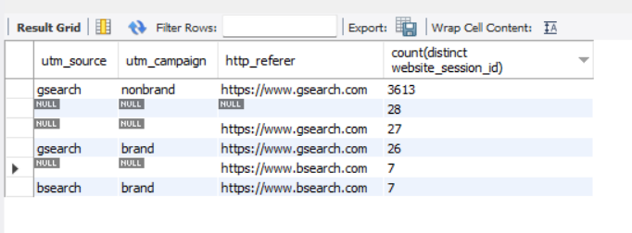

Conclusion-

Gsearch and non-brand campaign combination is driving the most visit on the website

Q2. Calculate session to order conversion rate

select count(b.order_id)/count(a.website_session_id) from `mavenfuzzyfactory`.`website_sessions` as a

left join `mavenfuzzyfactory`.`orders` as b on a.website_session_id=b.website_session_id

where a.created_at<'2012-04-12' and a.utm_source='gsearch' and a.utm_campaign='nonbrand'

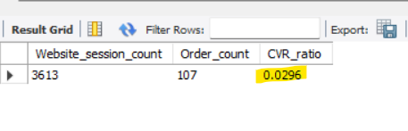

Conclusion-

Conversion Rate for sales is around 2% for Gsearch and non-brand campaign

Q3. Traffic Source Trends week by weeks analysis

select week(created_at),min(date(created_at)),count(website_session_id) from `mavenfuzzyfactory`.`website_sessions`

where created_at<'2012-05-10' and utm_source='gsearch' and utm_campaign='nonbrand'

group by 1;

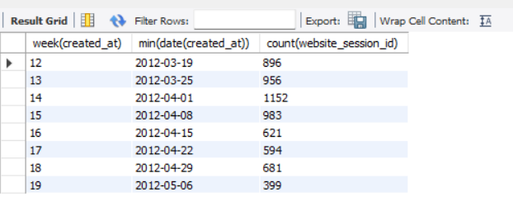

Conclusion-

There is considerable decline in users session after 8th April week

Q4. Session to order conversion rate by device type analysis

select device_type,count(distinct ws.website_session_id) as session_count,count(distinct order_id) as order_count,

count(distinct order_id)/count(distinct ws.website_session_id) as session_to_order

from `mavenfuzzyfactory`.`website_sessions` ws left join `mavenfuzzyfactory`.`orders` o on o.website_session_id=ws.website_session_id

where ws.created_at<'2012.-05-11' and utm_source='gsearch' and utm_campaign='nonbrand' group by 1;

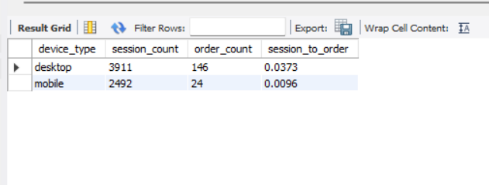

Conclusion-

Mobile devices have much lower conversion rate than desktop app

Q5. Device type segment traffic source trend analysis

select min(date(created_at)) as week_start,

count(distinct case when device_type='mobile' then website_session_id else null end) as mobile_session_count,

count(distinct case when device_type='desktop' then website_session_id else null end) as website_session_count

from `mavenfuzzyfactory`.`website_sessions` where created_at>'2012-04-15' and created_at<'2012-06-09' and utm_source='gsearch' and utm_campaign='nonbrand'

group by year(created_at),week(created_at) order by year(created_at),week(created_at)

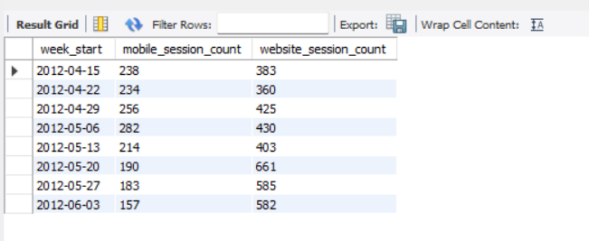

Conclusion-

Website sessions are increased after May 13th and Mobile sessions did not had much changes